Project Design Phase-II
Customer Journey Map
Date | 14 October 2026
Team ID
Project Name | Automated Network Request Management System
Maximum Marks | 4 Marks

Customer Journey Map Overview:
A Customer Journey Map visualizes the complete step-by-step experience of an end user interacting with the service. The journey spans 5 stages: Awareness & Need, Catalog Intake, Automated Flow Processing, Manager Approval, and Task Fulfillment.
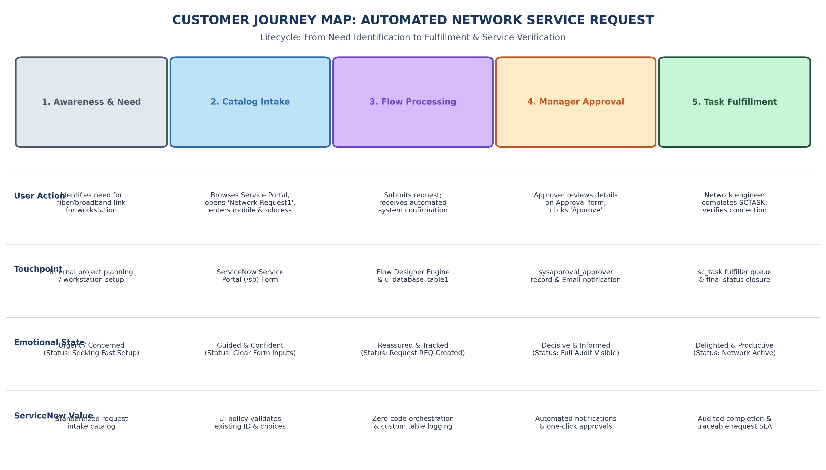
Figure 2.1: Customer Journey Map for ServiceNow Network Request Workflow

